Reinforcement Learning Laboratory
E0124065

EXP-1
CODE:
import random

class Environment:
def __init__(self):
self.state = 0
print("Environment initialized")

def reset(self):
self.state = 0
return self.state

def step(self, action):
if action == 0:
self.state = max(0, self.state - 1)
elif action == 1:
self.state = min(5, self.state + 1)
else:
pass

reward = -1
done = False

if self.state == 5:
reward = 10
done = True
elif self.state == 0 and action == 0:
reward = -5

return self.state, reward, done

class Agent:
def __init__(self):
pass

# Initialize components
env = Environment()
agent = Agent()
state = env.reset()

print(f"Initial state: {state}")

done = False
step_count = 0
episode_reward = 0

# Simulation loop
while not done:
action = random.choice([0, 1])
next_state, reward, done = env.step(action)
episode_reward += reward
step_count += 1

print(f"Step {step_count}: Action {action}, New State {next_state}, Reward {reward}, Done {done}")
state = next_state

print(f"\nEpisode finished after {step_count} steps with total reward: {episode_reward}")

OUTPUT:
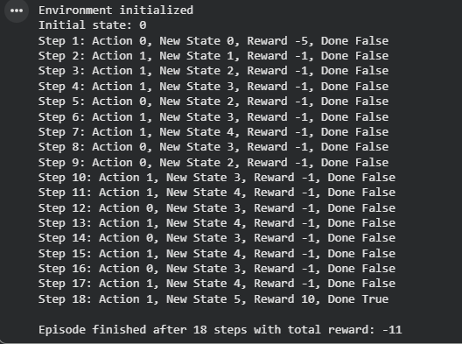
Exp 1.1
CODE:
import random

class Environment:
def __init__(self):
self.state = 0
print("Environment initialized: Treasure Hunt in 1D World")

def reset(self):
self.state = 0
return self.state

def step(self, action):

if action == 0:

self.state = max(0, self.state - 1)
elif action == 1:

self.state = min(10, self.state + 1)

reward = 0
done = False

if self.state == 10:
reward = 20
done = True

elif self.state == 5:
reward = -5

else:
reward = 0

return self.state, reward, done

class Agent:
def __init__(self):
pass

def choose_action(self):

return random.choice([0, 1])

env = Environment()
agent = Agent()
state = env.reset()

print(f"Initial state: {state}")

done = False
step_count = 0
total_reward = 0

while not done:
action = agent.choose_action()
next_state, reward, done = env.step(action)
total_reward += reward
step_count += 1

action_name = "Right (+1)" if action == 1 else "Left (-1)"
print(f"Step {step_count}: Action {action_name}, New State {next_state}, Reward {reward}")

state = next_state

print(f"\nGoal Reached!")
print(f"Episode finished after {step_count} steps with total reward: {total_reward}")

OUTPUT:
